Project 2: design of a cooling rib

Team: Wenjing Ke, Christopher Reinartz

Steps to solve the problem:

1. Set a initial temperature of the down side of steel T0
2. Solve the temperature of steel part
3. Get the heat flux $φ$ of steel-water interface
4. Solve the water part

1. Analysis of steel part:

Heat equation:

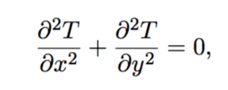

Boundary condition:

$λ\frac{∂T}{∂x}=h (T-T_{ext})$, left/right/top side

$T_{d}= T_{0}$, bottom edge, set an initial value

Discretization:

Heat equation:



$$\frac{T_{i+1,j}-2T_{i,j}+T_{i-1,j} }{{∆x}^{2}}+\frac{T_{i,j+1}-2T_{i,j}+T_{i,j-1} }{{∆y}^{2}}+ O\left({∆x}^{2}\right)+O\left({∆y}^{2}\right)=0$$

by Succesive OverRelaxation (SOR) method,

$$T_{i,j}^{k+1}=\left(1-ω\right)T_{i,j}^{k}+ \frac{ω}{\frac{2}{{∆x}^{2}}+ \frac{2}{{∆y}^{2}}} (\frac{T_{i+1,j}^{k}+ T_{i-1,j}^{k+1}}{{∆x}^{2}}+ \frac{T_{i,j+1}^{k}+ T_{i,j-1}^{k+1}}{{∆y}^{2}})$$

Neumann boundary condition:

left side:

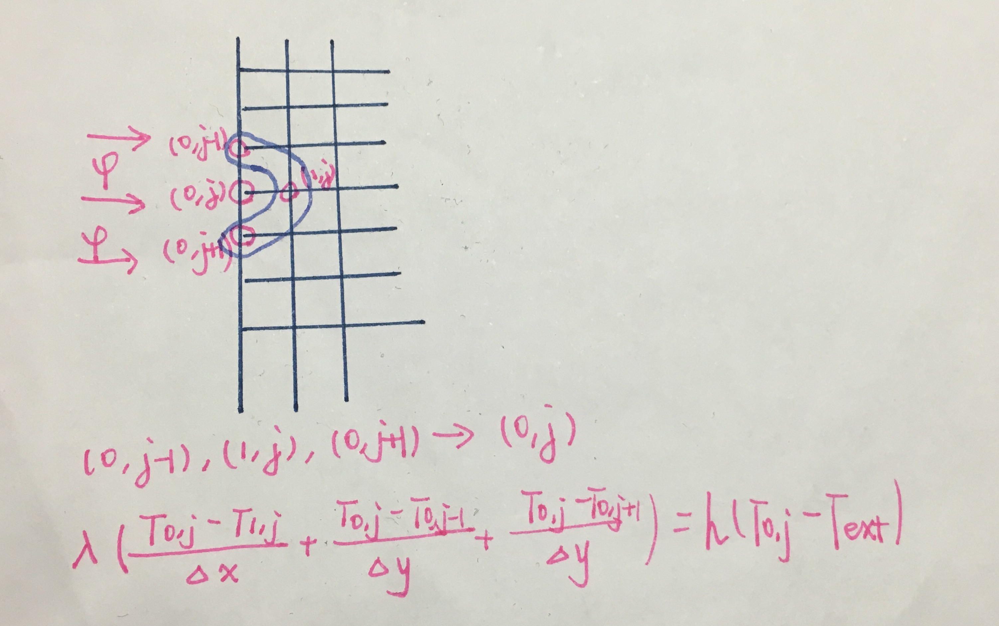

$λ(\frac{∂T}{∂x}+\frac{∂T}{∂y})=h \left(T-T_{ext}\right)$

$λ (\frac{T_{0,j}-T_{1,j}}{∆x}+ \frac{T_{0,j}-T_{0,j-1}}{∆y}+\frac{T_{0,j}-T_{0,j+1}}{∆y})= h_{l} ( T_{ext}-T_{0,j})$, 0<j<M, M is the number of points

$T_{0,j}=(T_{1,j}+ T_{0,j-1}+ T_{0,j+1}-T_{ext}* \frac{∆x{ h}_{l}}{λ})$/($3-\frac{∆x{ h}_{l}}{λ}$)

so as the right/top side

bottom side:

2. steel-water interface:

Heat flux $φ$ of steel-water interface:

$$φ= λ_{steel}(\frac{∂T_{steel}}{∂y}+\frac{∂T_{steel}}{∂x})$$

$$φ_{out }= φ_{in }$$

$λ_{steel}\frac{∂T_{steel}}{∂y}$ = - $λ_{water}\frac{∂T_{water}}{∂y}$

discretization:

3. water part

heat equation:

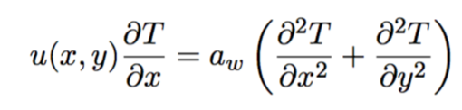

the velocity is:

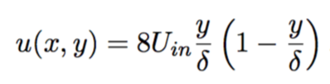

boundary condition:

left side: T=300K

top side: - $λ_{water}\frac{∂T_{water}}{∂y}= φ$

right side: $λ_{water}\frac{∂T_{water}}{∂x}=$ 0

bottom side: $λ_{water}\frac{∂T_{water}}{∂y}=$ 0

discretization:

set the Uin, upon the velocity equation, we can get:

$u_{i,j}=$ 8Uin $\frac{j*dy}{δ}$ (1- $\frac{j*dy}{δ}$)

$$u_{i,j}\frac{T_{i,j}-T_{i-1,j}}{∆x}=a_{w}\left(\frac{T_{i+1,j}-2T_{i,j}+T_{i-1,j} }{{∆x}^{2}}+\frac{T_{i,j+1}-2T_{i,j}+T_{i,j-1} }{{∆y}^{2}}\right)$$

$$T_{i,j}= \frac{T_{i-1,j}+\left(\frac{T_{i+1,j}+T_{i-1,j} }{{∆x}^{2}}+\frac{T_{i,j+1}+T_{i,j-1} }{{∆y}^{2}}\right)*\frac{∆xa_{w}}{u_{i,j}}}{1+\left(\frac{2}{{∆x}^{2}}+ \frac{2}{{∆y}^{2}}\right)*\frac{∆xa_{w}}{u_{i,j}}}$$

boundary condition:

|  |  |
| --- | --- |
| Left side | $$T_{0,i}=300$$ |
| Right side | $T_{M-1,i}$ = $T_{M-2,i}$ |
| Top side | $$φ_{i }= {-λ}_{water} \left(\frac{T_{i,1}- T_{i,0}}{∆y}+\frac{T_{i+1,0}- T_{i,0}}{∆x}+\frac{T_{i-1,0}- T_{i,0}}{∆x}\right)$$ $$T_{i,0}= \frac{\frac{T_{i,1}}{∆y}+\frac{T_{i+1,0}+ T_{i-1,0}}{∆x}+φ_{i }/λ}{\frac{2}{∆x}+ \frac{1}{∆y}}$$ |
| Bottom side | $T_{i,M-1}$ = $T_{i, M-2}$ |